Dashboard
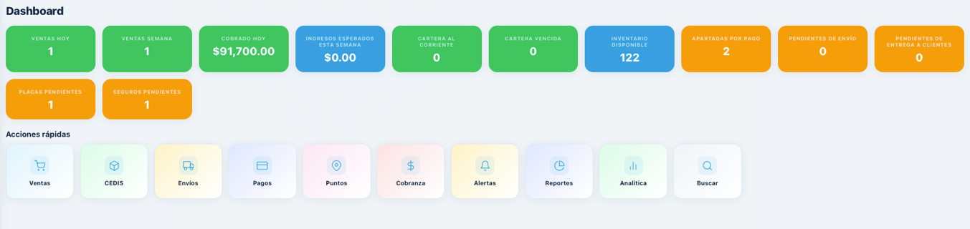

Dashboard
All buttons in the Dashboard section must be selectable, so they redirect the user to their respective screens with the corresponding information.
- The "Cobrado hoy" button is currently counting an order that had no Stripe payment. It must only count orders that have been verified through Stripe.
[Image 1 — Dashboard screenshot showing all metric buttons and Ǫuick Actions panel, as shown in original document]

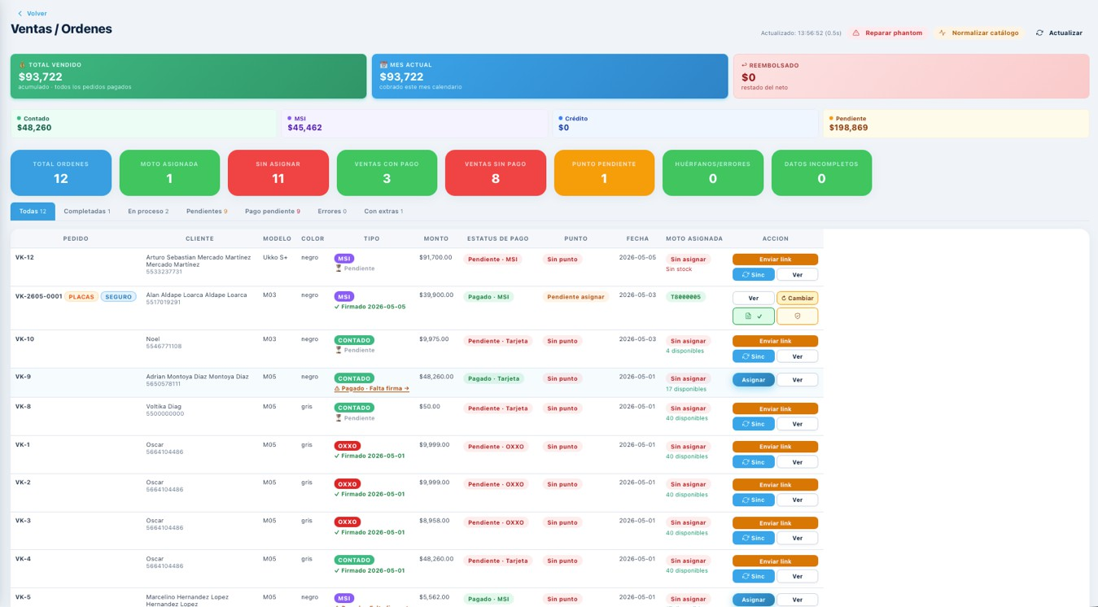
Ventas
The top cards must display order indicators broken down by order type. Each independent card must show the order count for a specific type (MSI, Contado [Cash], Crédito [Credit]), where the total amount for each order type is currently displayed.

These buttons must be able to filter the list so the user can see what corresponds to each concept.

What is the difference between "pending orders" and "orders pending payment"? What criteria is being considered here?

Required Filters
We need to be able to filter by the following criteria:

A. All
- B. Completed (Completado) — these orders have payment confirmed AND all contracts signed

C. By payment method:
  - Contado (Cash)
  - MSI (Months without interest)
  - Crédito (Credit)
- D. With assigned motorcycle (Moto asignada)
- E. Motorcycle pending assignment Moto no asignada)
- F. With pending payment (pago pendiente)
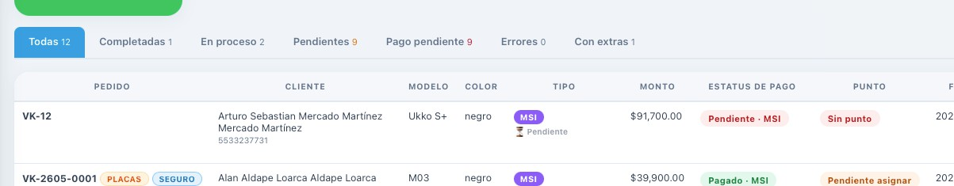

The name format is currently displaying as: "First Name" "Last Name 1" "Last Name 2" "Last Name 1", "Last Name 2" — duplicating the last names.

LAST NAMES MUST NOT BE DUPLICATED. Review the connections with the configurator or the corresponding forms and fix this error.

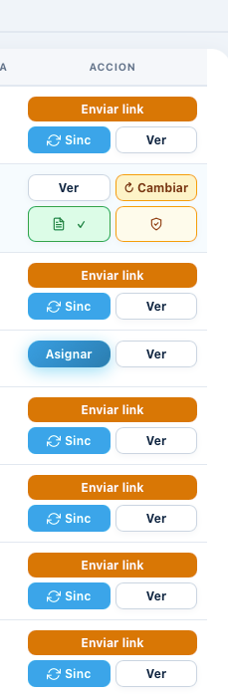
Sales Order Actions
The actions available per sales order type are not properly organized.
The actions that must be visible in the main panel are the following:

- 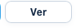 — Ver [Image 5 — "Ver" button] This option opens a window with all the information for that sale.
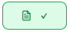
-  — Sinc (Sync) [Image C — "Sinc" button] This button must not exist. The order status must be updated automatically for all orders when the page is refreshed using the Refresh / "Actualizar" button at the top of the screen.
— Documentos This button opens a window with the full list of documentary evidence for the purchase, as viewable and downloadable files in their corresponding formats. Documents to display for MSI and Contado (Cash) orders:
- Completed and signed contract with the customer's data, timestamp, purchase information, and Cincel electronic signature exactly as signed by the customer at the time of purchase.
- Stripe payment receipt sent to the customer.
- Full purchase summary and all terms.
- For Crédito (Credit) orders, the window must include:
- Credit contract with all customer information, timestamp, purchase details, electronic signature, and all required elements.
- Customer documents submitted through Truora at the time of the credit application:
- Official government-issued ID (INE or PASSPORT)
- CURP (with CDC validation acknowledgment and Truora "same OK" verification)
- Credit capacity report
- Stripe down payment receipt
- Full transaction summar
-  — Defense Dossier Button [Image 8 — Shield icon button] This button contains the complete payment information.

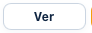

Button Layout

The buttons must be displayed as follows:

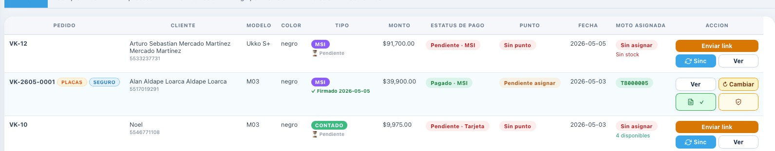

Point and Motorcycle Assignment Columns

"Punto" column: When no delivery point has been assigned, add an "Asignar punto" button. This button will display the dropdown list of available points so the user can assign the delivery point for that motorcycle. (See image for reference.)

"Assigned Motorcycle" column: When no motorcycle has been assigned, add an "Asignar moto" button. This button will display the dropdown list of available units so the user can assign the motorcycle for that order. (See image of the button placement for reference.)

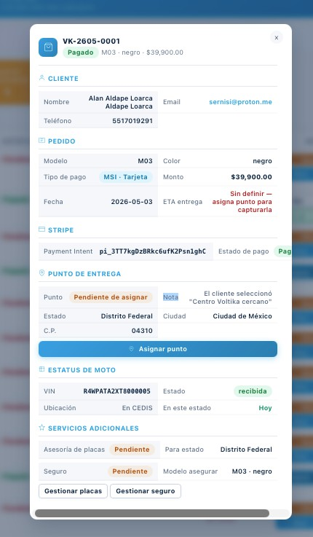
Ventana “Ver”
1
En caso de MSI y Contado
"View" Window — MSI and Contado (Cash)
Orders

[Image 12 — View window for order VK-2C05-0001, showing Customer, Order, Stripe, Delivery Point, Motorcycle Status, and Additional Services sections, as shown in original document]

- Customer section: Fix the last name duplication error — review the connections with the corresponding forms.

- Motorcycle Status section: Add 2 buttons to this section. We need to be able to both “asignar” and “desasignar” units from this portal.
2

THE ASSIGNMENT AND UNASSIGNMENT OF UNITS MUST BE REFLECTED IN THE INVENTORY WITHIN THE CEDIS PANEL.

RULES:

A single VIN number (motorcycle) CANNOT be assigned to more than one order.

  - Two orders CANNOT share the same assigned
VIN number

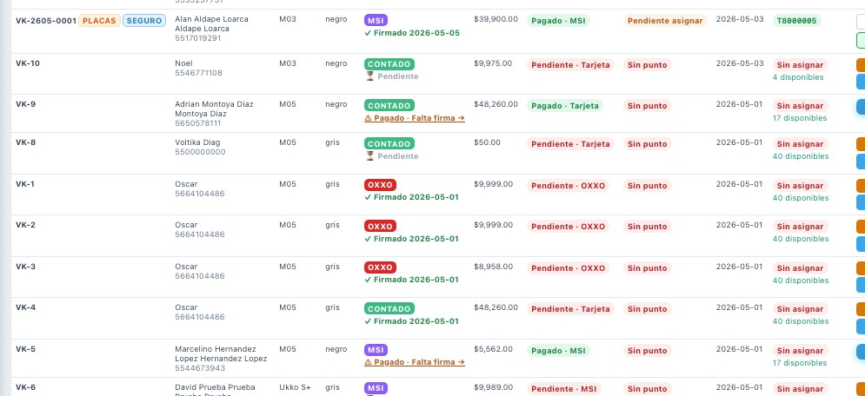
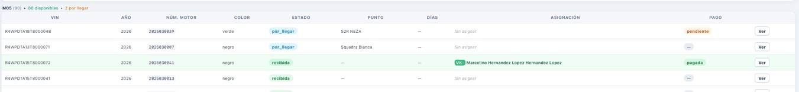
2
1

Image 2 shows that unit R4WPDTA15000072 is assigned to order VK-5 (Marcelino Hernandez Lopez), yet in the Sales panel that order shows no unit assigned.
Additionally, in the CEDIS panel, the corresponding order number for that customer does not appear. (Reference marker 1 in original image)
[Image 14 — CEDIS panel showing the unit list with the row for Marcelino Hernandez Lopez highlighted (reference marker 1), as shown in original document]

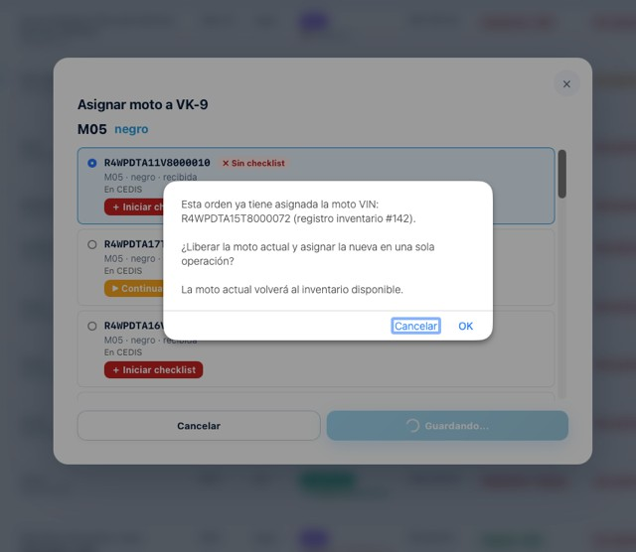
When attempting to assign a motorcycle to order VK-G (reference marker 3), the system shows a message stating that order already has unit R4WPDTA15T8000072 assigned — which is the same VIN assigned to order VK-5.

This is a database connection and communication error.

The following rules must be enforced:
- When a VIN number is assigned to an order, it cannot be assigned to any other
order. Two orders cannot share the same assigned VIN number.

- When a VIN number is assigned to an order, this action must be reflected in the CEDIS panel — when sent to a point of sale, in the checklists, etc. There must be full consistency across all screens of the panel, integrating this link throughout the entire platform environment. The same applies when a unit is unassigned or any change is made.
- To assign a new VIN number to an order that already has one assigned, the previous VIN must first be unassigned, and only then can the new VIN be assigned.
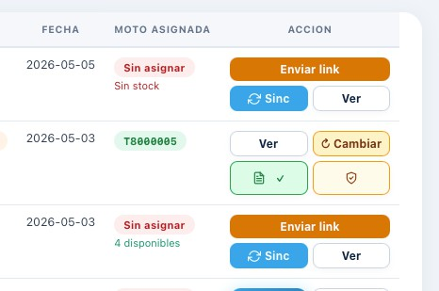

The full VIN number must be completly visible for any assigned motorcycle.

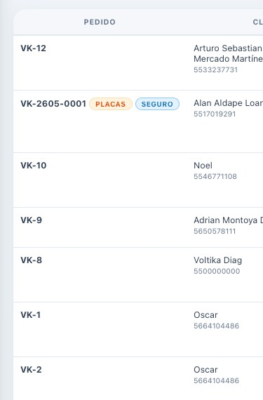
Order Numbering and Customer Information
[Image 1C — Order list with PEDIDO and CLIENTE columns, orders VK-12 through VK-2, with the name/phone area circled in red, as shown in original document]
  - There must be a sequential numbering system across all orders.
  - Use the format: VK-1826- [consecutive number]

  - The customer's email address must also appear in the customer information area.

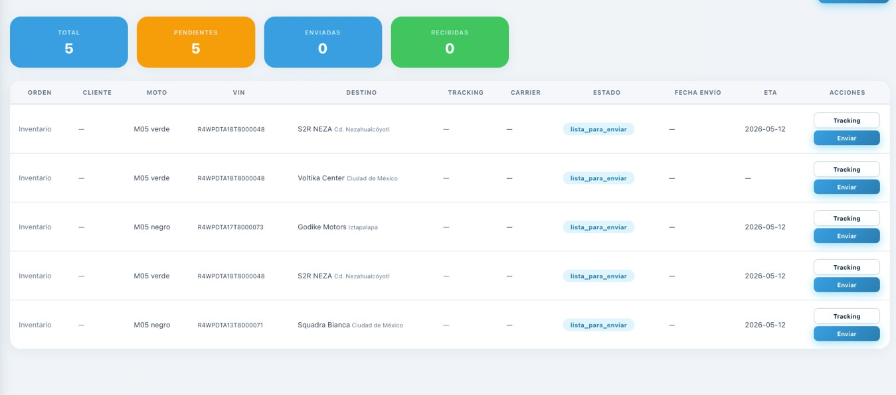
Envios

Shipping (Envíos)
When VIN numbers were reassigned to points, duplicate shipping events were created. A restriction must be implemented so that only one shipping order per VIN number is allowed.
In the event of a duplicate, the system must:
- Prompt the user to select the correct shipping record after any change is made.

Mark all previous (superseded) shipping records as "Completado no exitoso."
[Image 17 — Shipping panel showing 5 pending shipments all with status "lista_para_enviar" (ready to ship), with duplicate VIN entries visible, as shown in original document]

Solicitudes
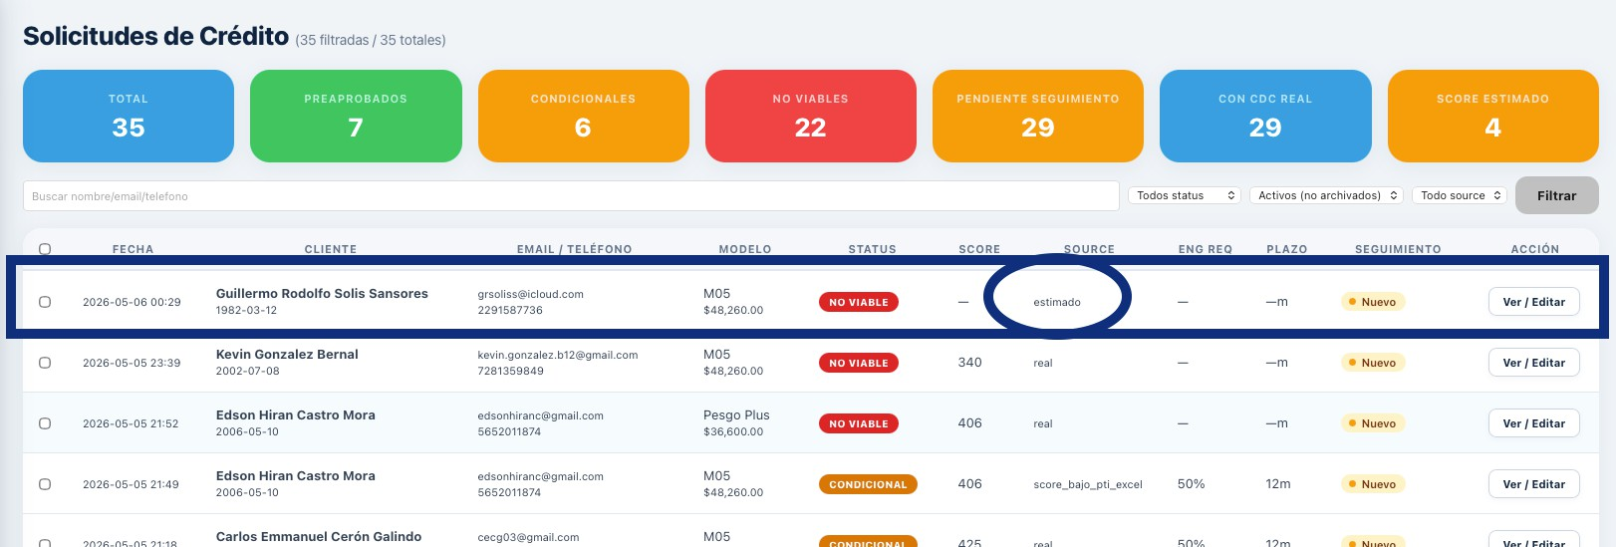

# Voltika — Urgent fix before WhatsApp mass send

**Priority:** Critical
**Deadline:** Before 9:00 AM on Thursday (mass send day)

## The bug

**Test case: Guillermo Solis Sansores (#47)**

System shows NO_VIABLE with text “Cliente sobreendeudado o con morosidad activa”, but the client has NO delinquency. Data:

- PTI: 7%
- Active accounts: 0
- DPD90: 0
- Required monthly payment: $0
- Source: “Score estimado” (CDC was not consulted)

The problem: when CDC does not respond and the algorithm falls back to PTI-only, the system incorrectly sends the case to NO_VIABLE with wrong text.

## What I need you to do

When `source === 'estimated'` (CDC not consulted), treat the case as CONDITIONAL:

- Status: CONDITIONAL
- Minimum down payment: 50%
- Maximum term: 12 months
- Banner: yellow
- Recommendation text: “No se pudo consultar Círculo de Crédito. Aprobar con condiciones conservadoras o reintentar consulta.”

That’s it. One branch, one outcome.

## What you must NOT touch

- Current V3 algorithm logic

- The 2 previous fixes already in production (CDC sin score, Score bajo + PTI excelente)
- PREAPROBADO / CONDICIONAL / NO_VIABLE screens
- Truora, Stripe, configurator, contracts
- PLD Check (still pending separate task)
- Manual override feature (still pending separate task)

Do not refactor or improve anything else. Just add the new branch for `source === 'estimated'`.

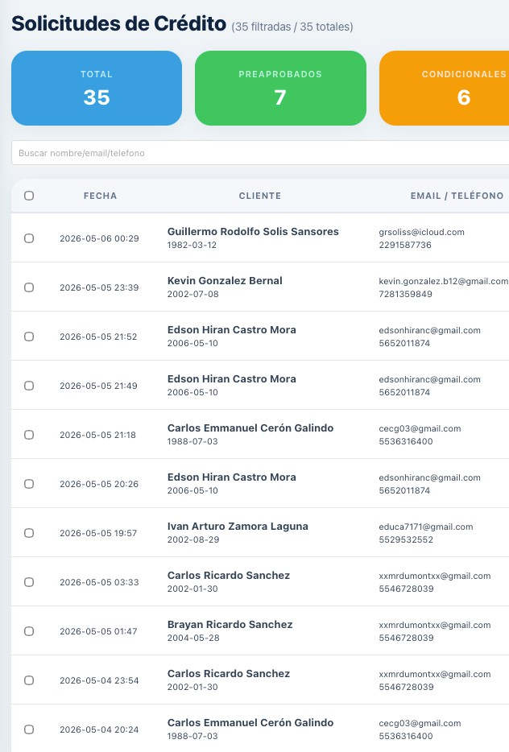
All requests must have a consecutive entry number, which must be linked to the order generated from them.
How this relationship must be created: When a request is closed and converted into an order, the "View" panel on the Sales / Orders page must — and only there
— display a line indicating which request is the predecessor of that order.

.

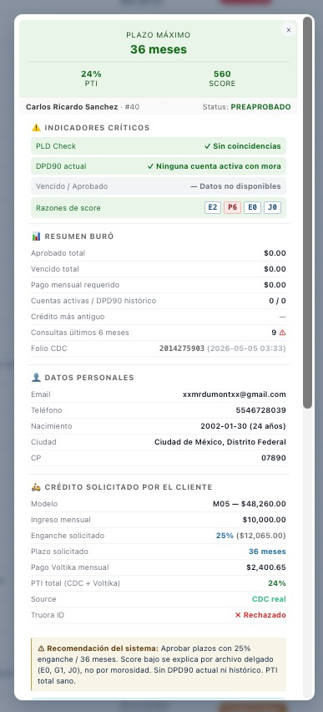
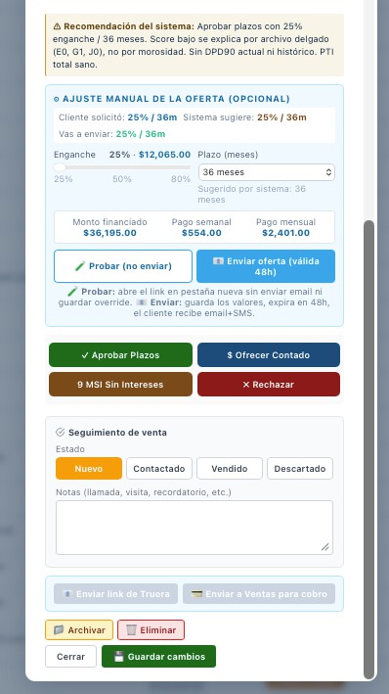
1

- The previous images show the credit application of Carlos Ricardo Sanchez. His application shows as pre-approved and everything is in order until it reaches the Truora identity verification step, which comes back as rejected. Passing this verification is a direct prerequisite for credit approval. Therefore, just as there are recommendations based on the bureau (credit bureau) score, a user who is rejected in this identity verification must not be allowed to have their credit approved.

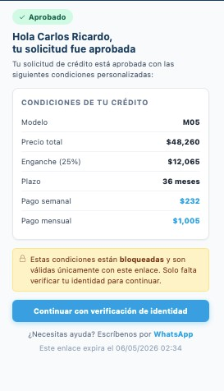
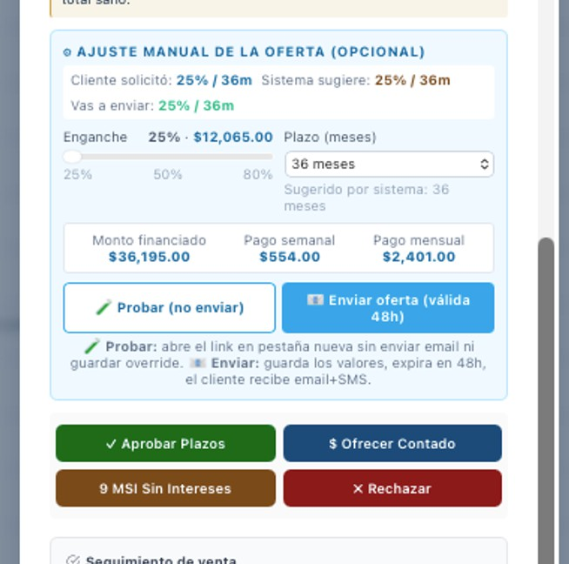
- When sending a new offer, the amounts are not being calculated correctly. We must verify that the offer being sent matches the correct credit calculation approved in
the system, and that there are no errors outside of this calculation within the
collections (cobranza) system.

